1. Process: Result Process
2. Purpose: Compute & print various result reports. Handle reval/retotal/grace marks and compute & print results again.
3. Screens in this process

|  |  |  |
| --- | --- | --- |
| **Screen Name** | **Purpose** | **Access By User Role** |
| Compute Grade Points | Compute grade points | University Exam Dept. |
| Print Coursewise Result sheet |  | University Exam Dept.,  College Exam Dept. user |
| Print semester end result sheet |  | University Exam Dept.,  College Exam Dept. |
| Print Grade Card |  | University Exam Dept.,  College Exam Dept. |
| Print Transcript |  | University Exam Dept. |
| View My Result (Gradecard) |  | Student |
| Apply for Retotal/Reeval/Grace marks |  | Student |
| Print Reval Student Application List |  | University Exam Dept. |
| Enter Reval/Retotal Marks |  | University Exam Dept. |
| Enter Grace Marks |  | University DR |
| Compute Grade Points After Reval |  | University Exam Dept. |
| Print re-totalling/reval Result |  | University Exam Dept. |
| Print Result Notification |  | University Exam Dept. |

4.1 Compute Grade Points

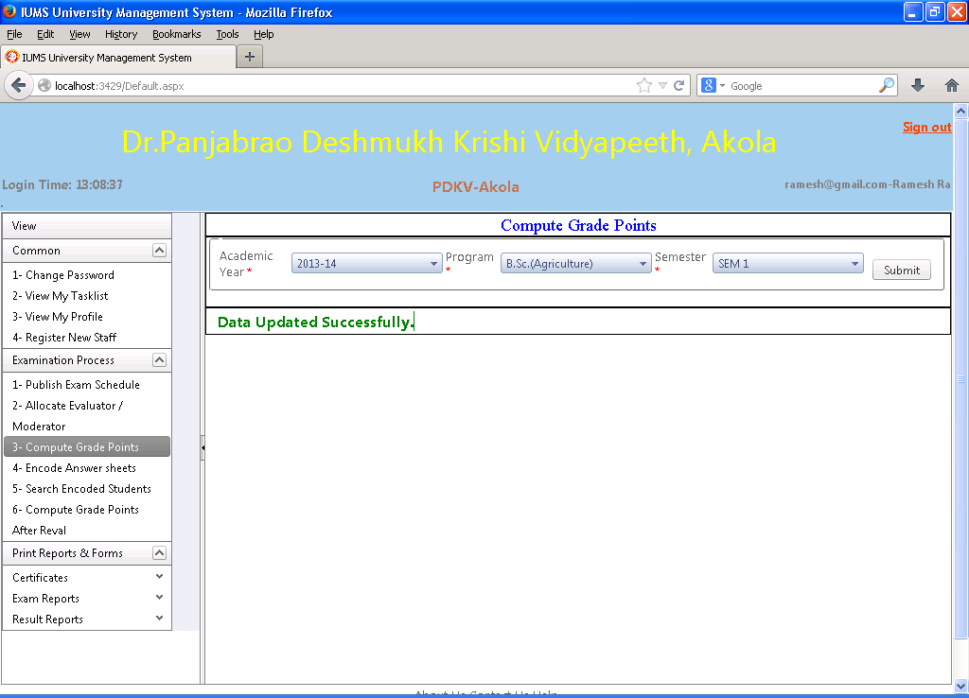

Screen Operation: Select academic year, program and semester. Click on Submit button. The grade points of all students in the selected program/semester (across all colleges) will be computed and updated in the database. If there is any error, the same will be displayed on the screen, otherwise a message ‘Data updated successfully’ will be displayed.

4.2 Print Coursewise Result sheet

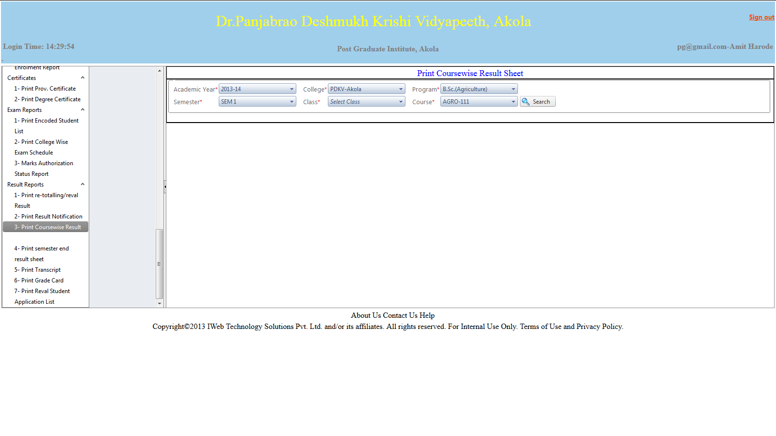

Screen Operation: Select academic year, college, program, semester, class and course.

Click on Search button. The report showing the result of the selected course will open in a separate window as follows on the next page.

Print Coursewise Result sheet (report)

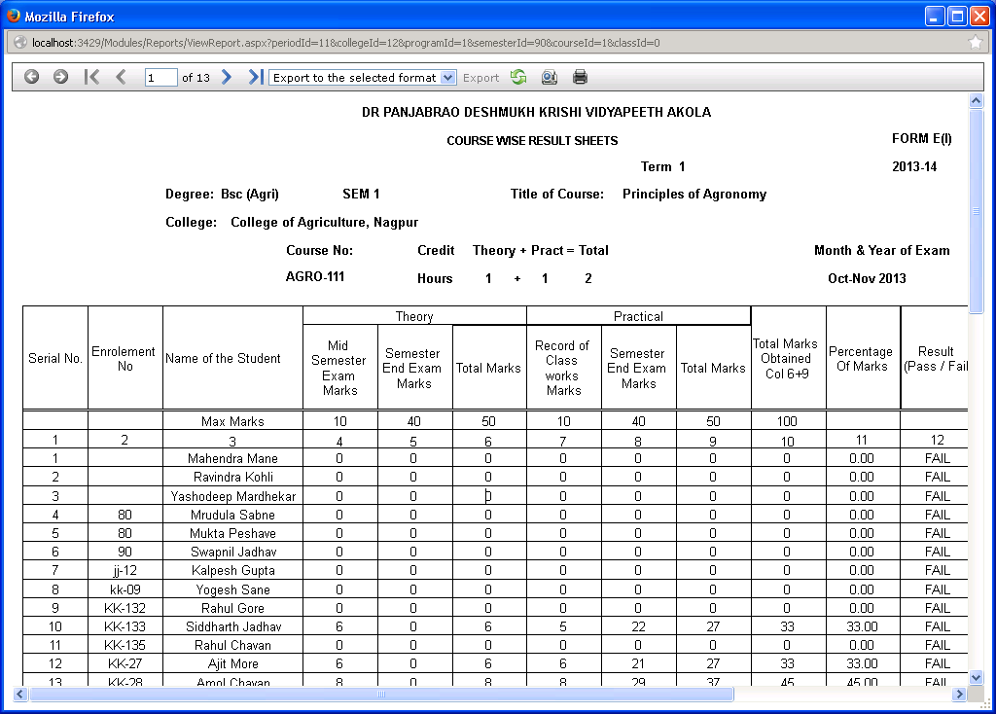

Click on the Print icon to print the report.

4.3 Print semester end result sheet

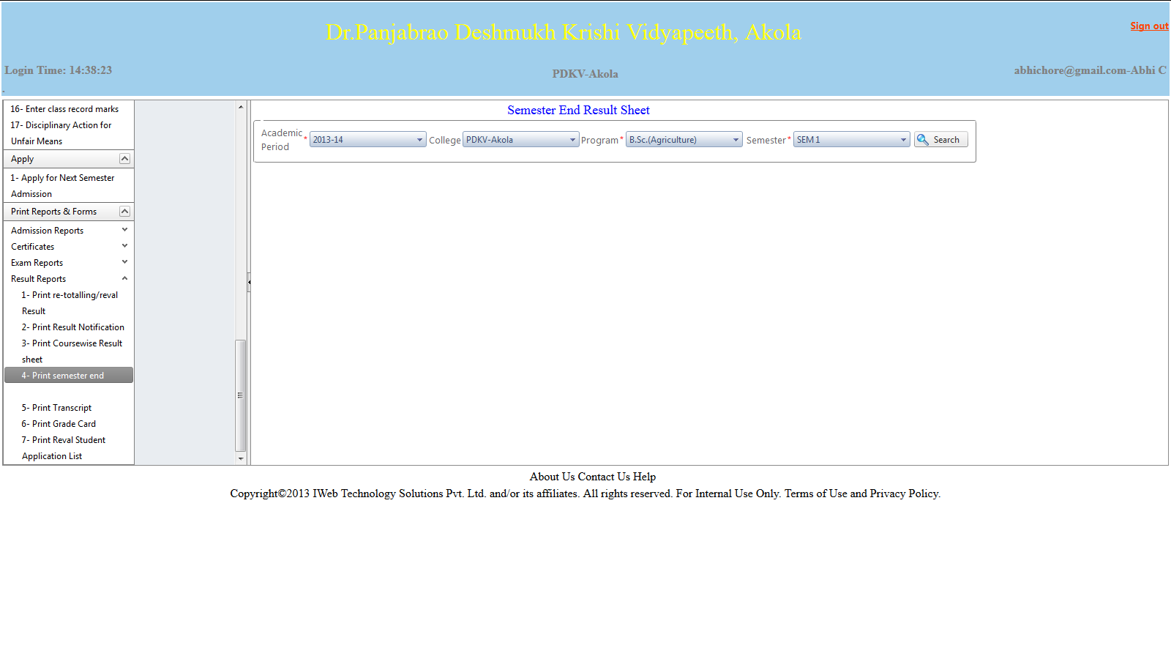Screen Operation: Select academic year, college, program and semester. Click on Search button.

The report showing semester end result for all the students in the selected college/program/semester will open in a separate window as follows on the next page.

Print semester end result sheet (report)

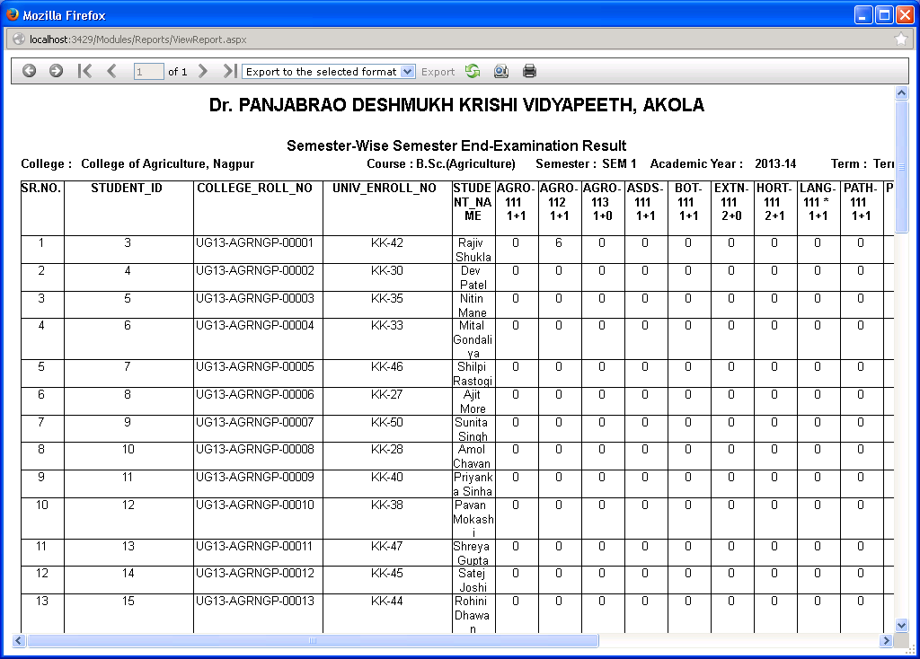

Click on the Print button to print the report.

4.4 Print Grade Card

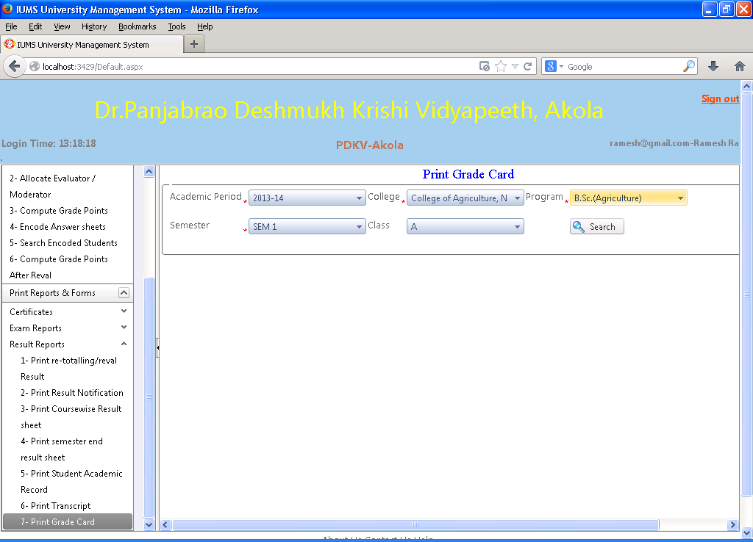

Screen Operation: Select academic year, college, program, semester & class. Click Search button.

The Grade cards of all students in the selected college/program/semester/class will be displayed in a separate window as follows on the next page.

Print Grade Card (Report)

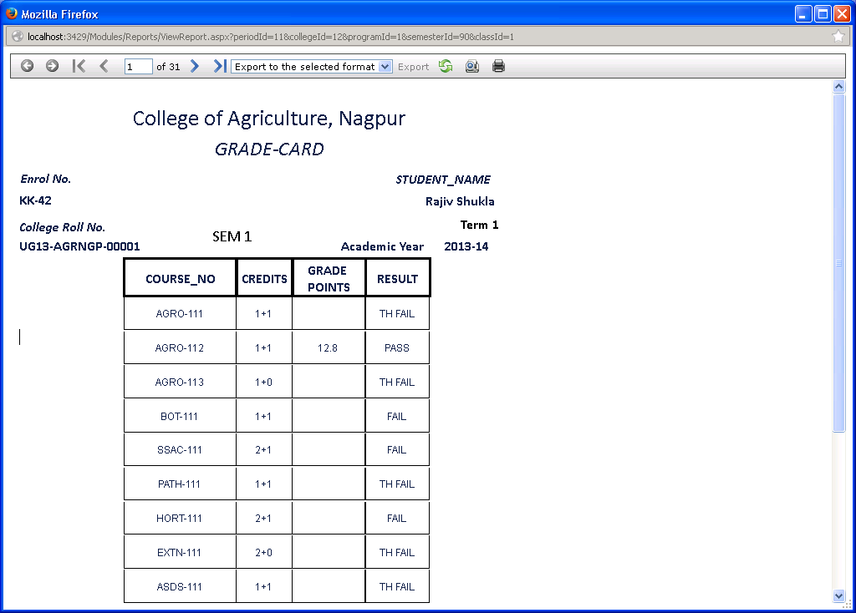

Click on the Print button to print the grade cards.

4.5 Print Transcript

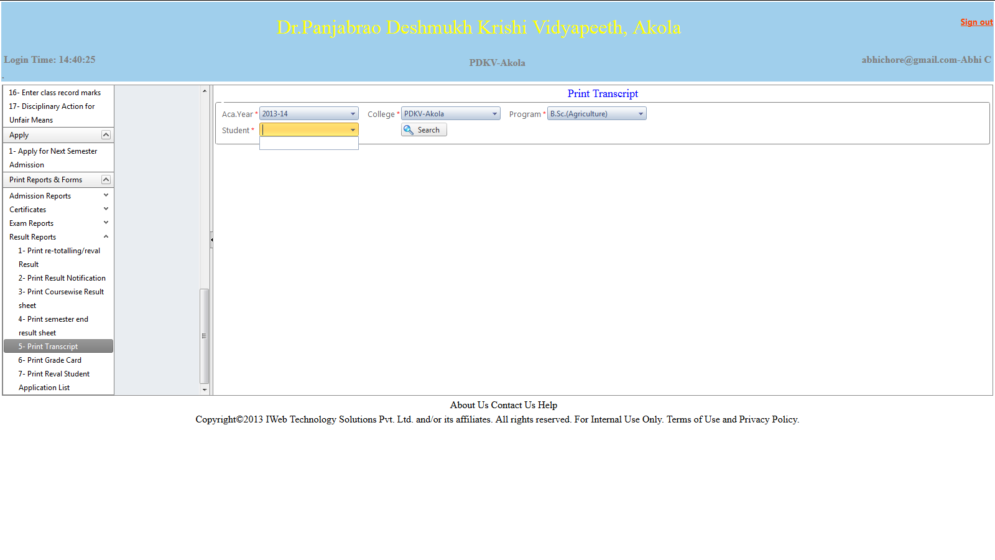

Screen Operation: Select academic year, college, program, semester & class. Click on Search button.

The report showing transcript of all students in the selected year, college, program, semester & class will be displayed in a separate window as follows on the next page.

Print Transcript (Report)

4.6 View My Result (Gradecard)

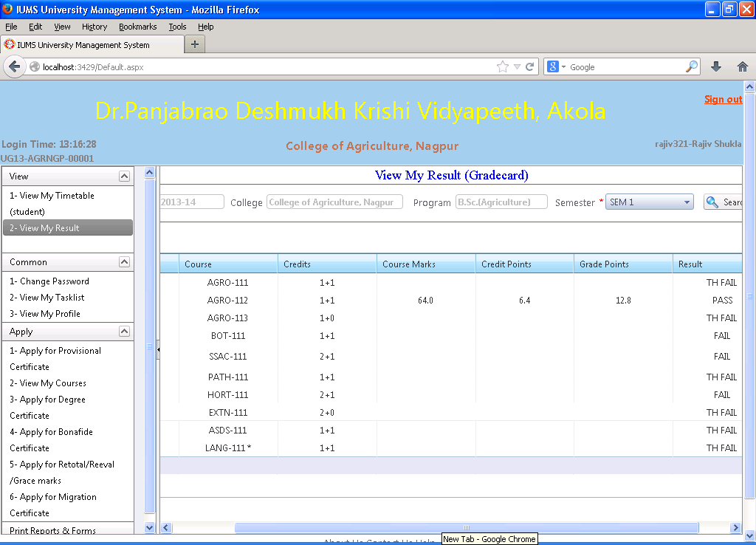

Students can see their own grade card online once the results are published.

Screen operation: Academic year, college, program are all already pre-selected for the student and cannot be changed. Select the semester and click Search.

The grade card for the selected semester will be displayed as shown above.

4.7 Apply for Retotal/Reeval/Grace marks

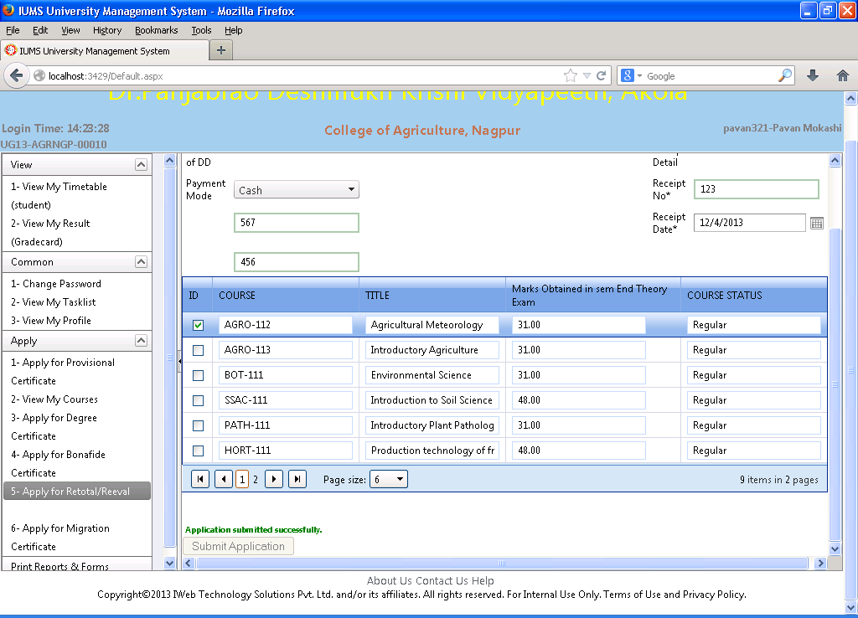

After viewing the grade card, the student can then go on to apply online for re-valuation, re-totalling or grace marks. For this, the student should first make a payment of the prescribed fees and collect the receipt of payment as these receipt details will be required to be input along with the online application.

Screen Operation: Input the fee payment details as follows:

Payment Mode: Select from the dropdown list from cash, cheque, or DD

Receipt No.: Input the receipt no. of payment

Receipt Date: Input the date on the payment receipt

The list of courses for which student is registered and recently conducted exam is displayed.

Check the checkbox against the course for which you would like to apply. The course title, marks obtained, and course status whether regular/repeater is also displayed for each course.

Click the button ‘Submit Application’ .

4.8 Print Reval Student Application List

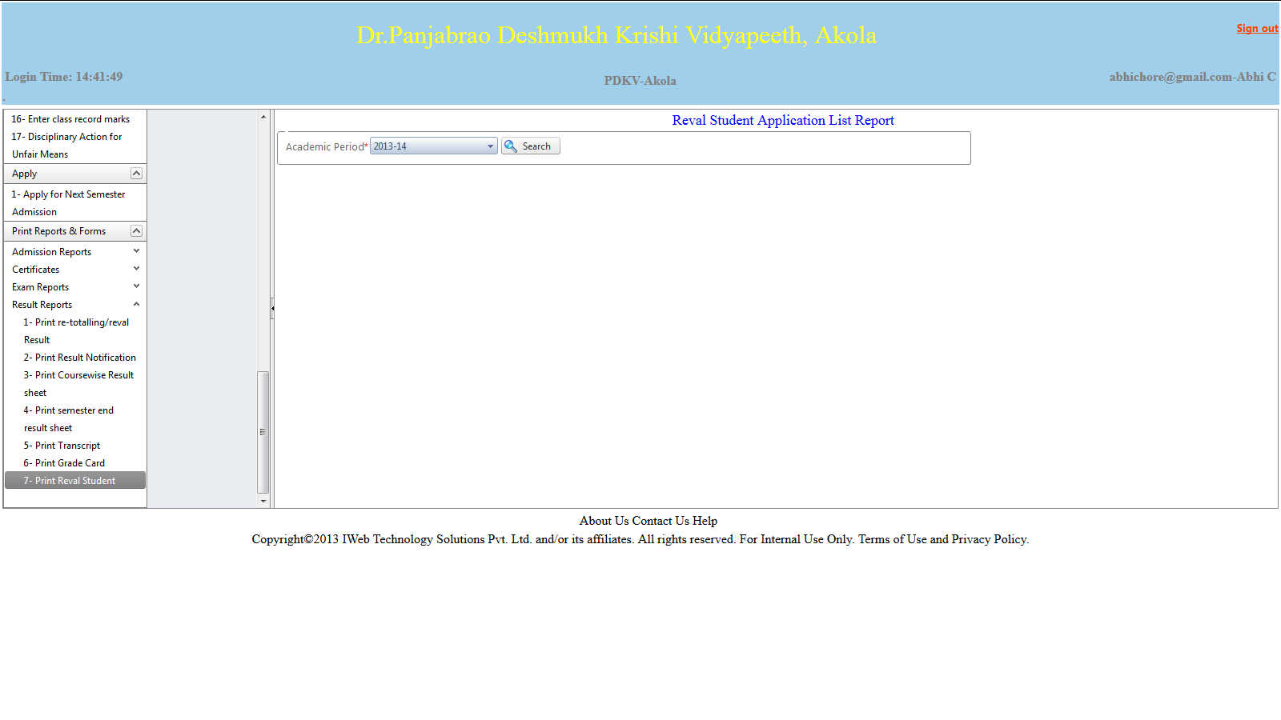

Screen Operation: Select the academic period. Click Search button. The report showing list of students who have applied for Reval is displayed in a separate window as follows.

Print Reval Student Application List

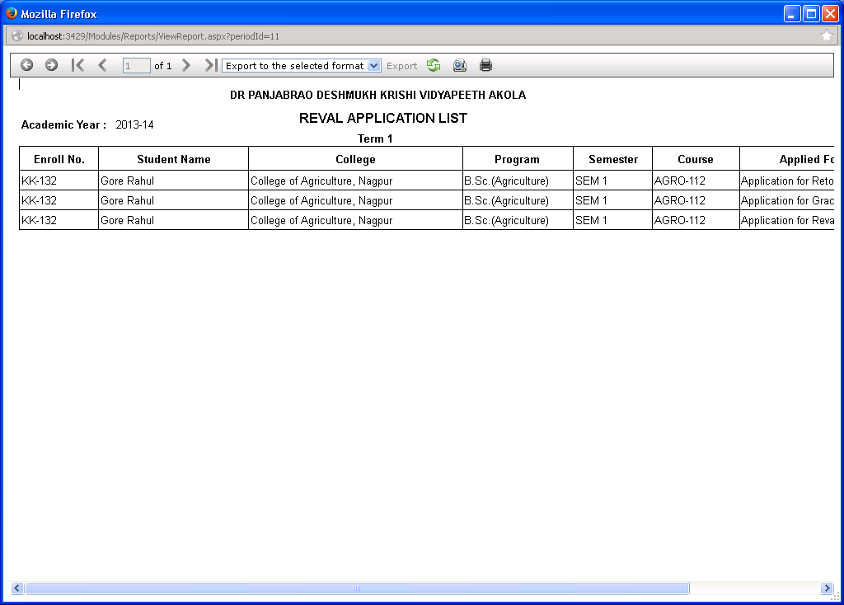

4.9 Enter Reval/Retotal Marks

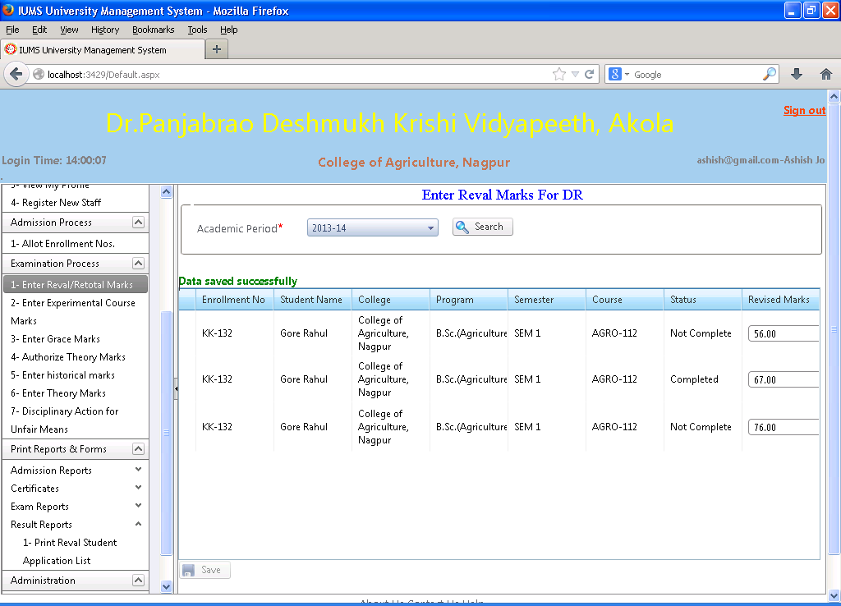

Screen Operation: Select academic period. Click Search button. The list of students who have applied for revaluation is displayed. Input the marks received from revaluation examiner in the Revised Marks textbox against each student. Click Save button to save the data. The message ‘Data saved successfully’ will be displayed.

4.10 Enter Grace Marks

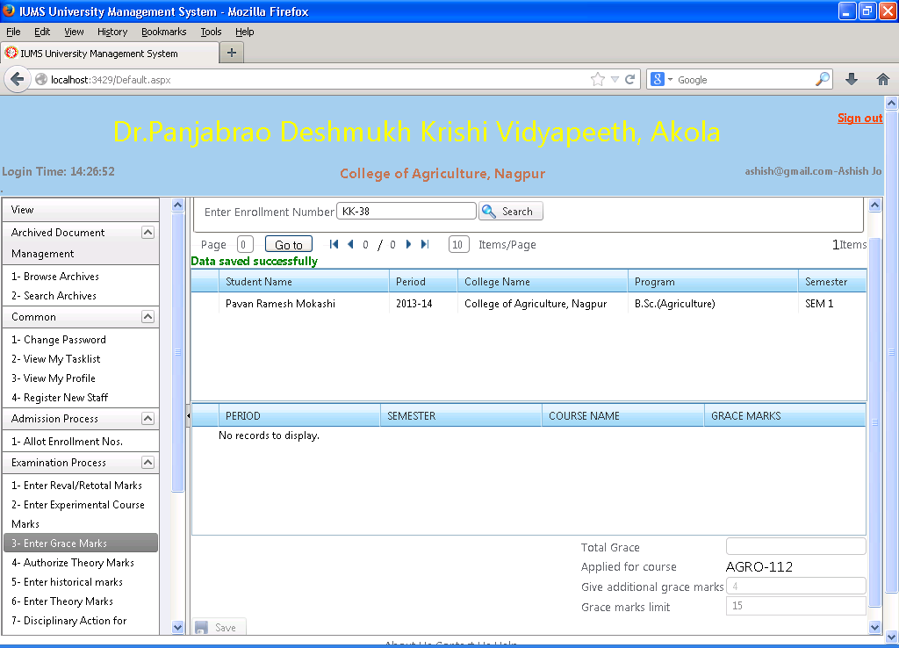

Screen Operation: Input the enrollment number of the student who is to be given grace marks. Click Search button. The screen displayed 2 grids. The details of the student are displayed in the first grid. In the second grid, data is displayed if the student has received grace marks at any time in the past – academic period, semester, course and grace marks are displayed.

At the bottom of second grid, Total grace marks obtained are displayed along with the course name for which grace marks application is made.

Input the grace marks to be given at this time. The total grace marks limit is displayed for verification.

If the after giving grace marks this time, the total grace marks remains within limit, click Save button to save the data. If the grace marks exceed limit, the data cannot be saved.

4.11 Compute Grade Points After Reval

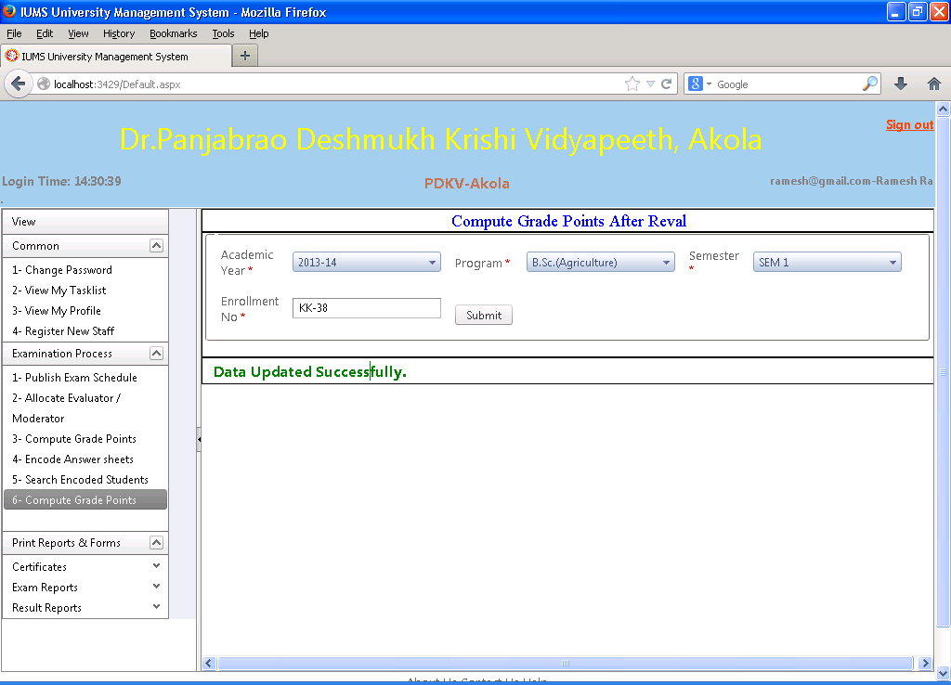

After entering reval/retotal/grace marks of the students, grade points have to be computed again to print the revised results of the students.

Screen operation: Select Academic year, program, semester. Input enrollment no. of the student. Click Submit button. The grade points of the student will be computed again. The message ‘Data saved successfully’ will be displayed.

4.12 Print re-totalling/reval Result

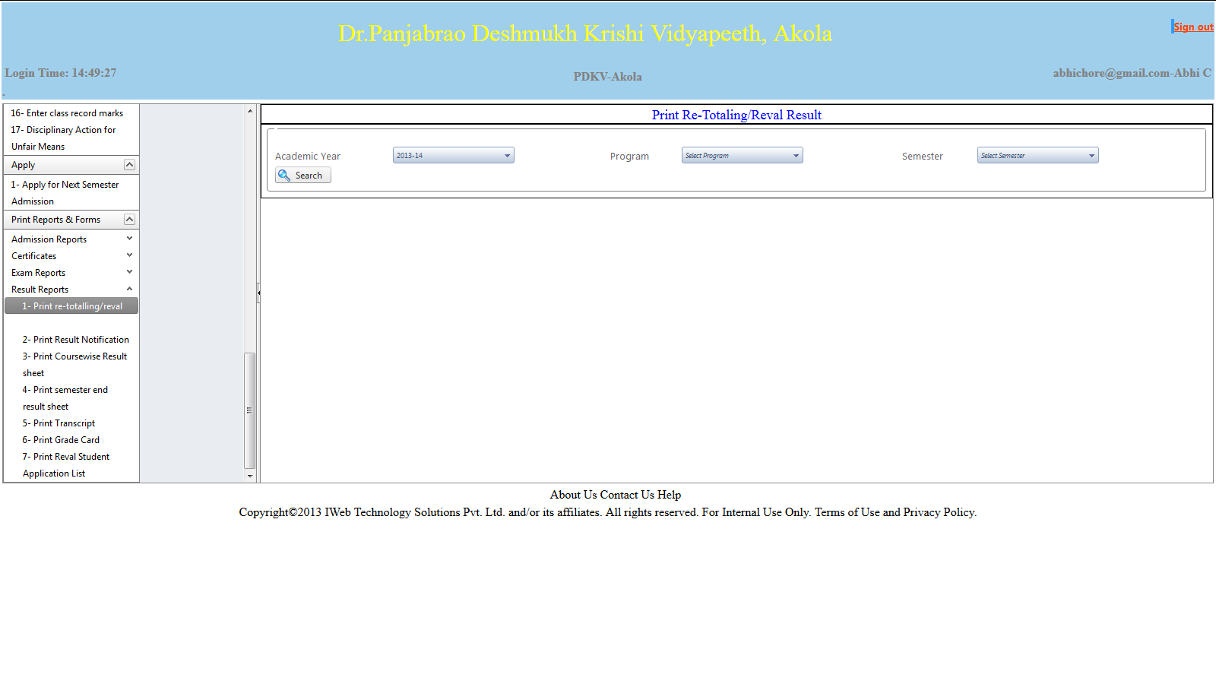

Screen Operation: Select academic year, program, semester. Click Search. The report of reval/retotal is displayed in a separate window as follows.

Print re-totalling/reval Result (Report)

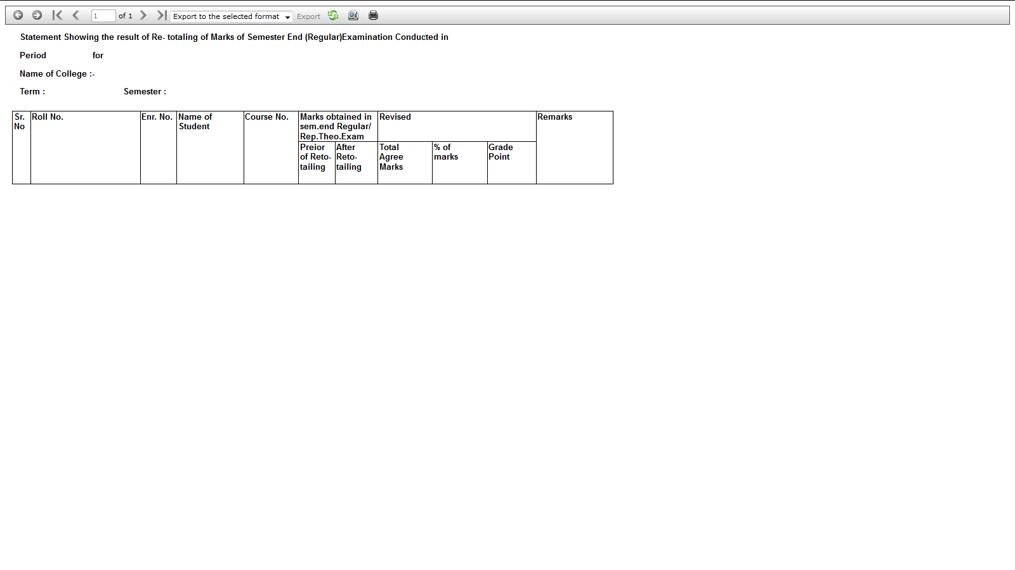

The report shows student roll no. , enrollment no., name, course no. , Marks obtained in regular exam before and after re-totaling and revised marks, revised percentage and grade points.

4.13 Print Result Notification

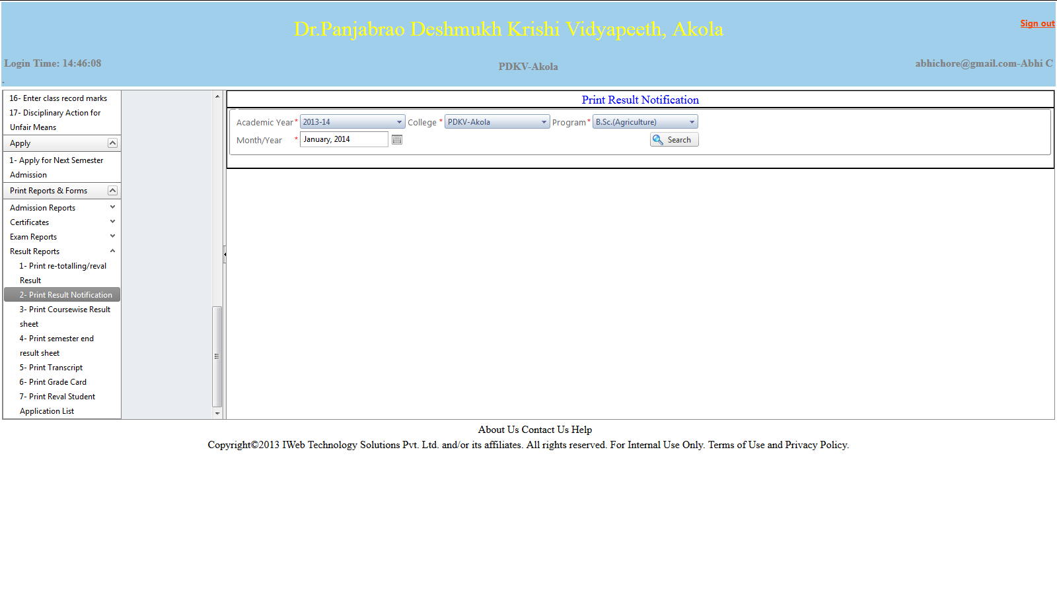

Screen Operation: Select academic year, college, program and month/year of notification.

Click Search. The result notification report will be displayed in a separate window as follows.

Print Result Notification (Report)

